HMBMan 5.4

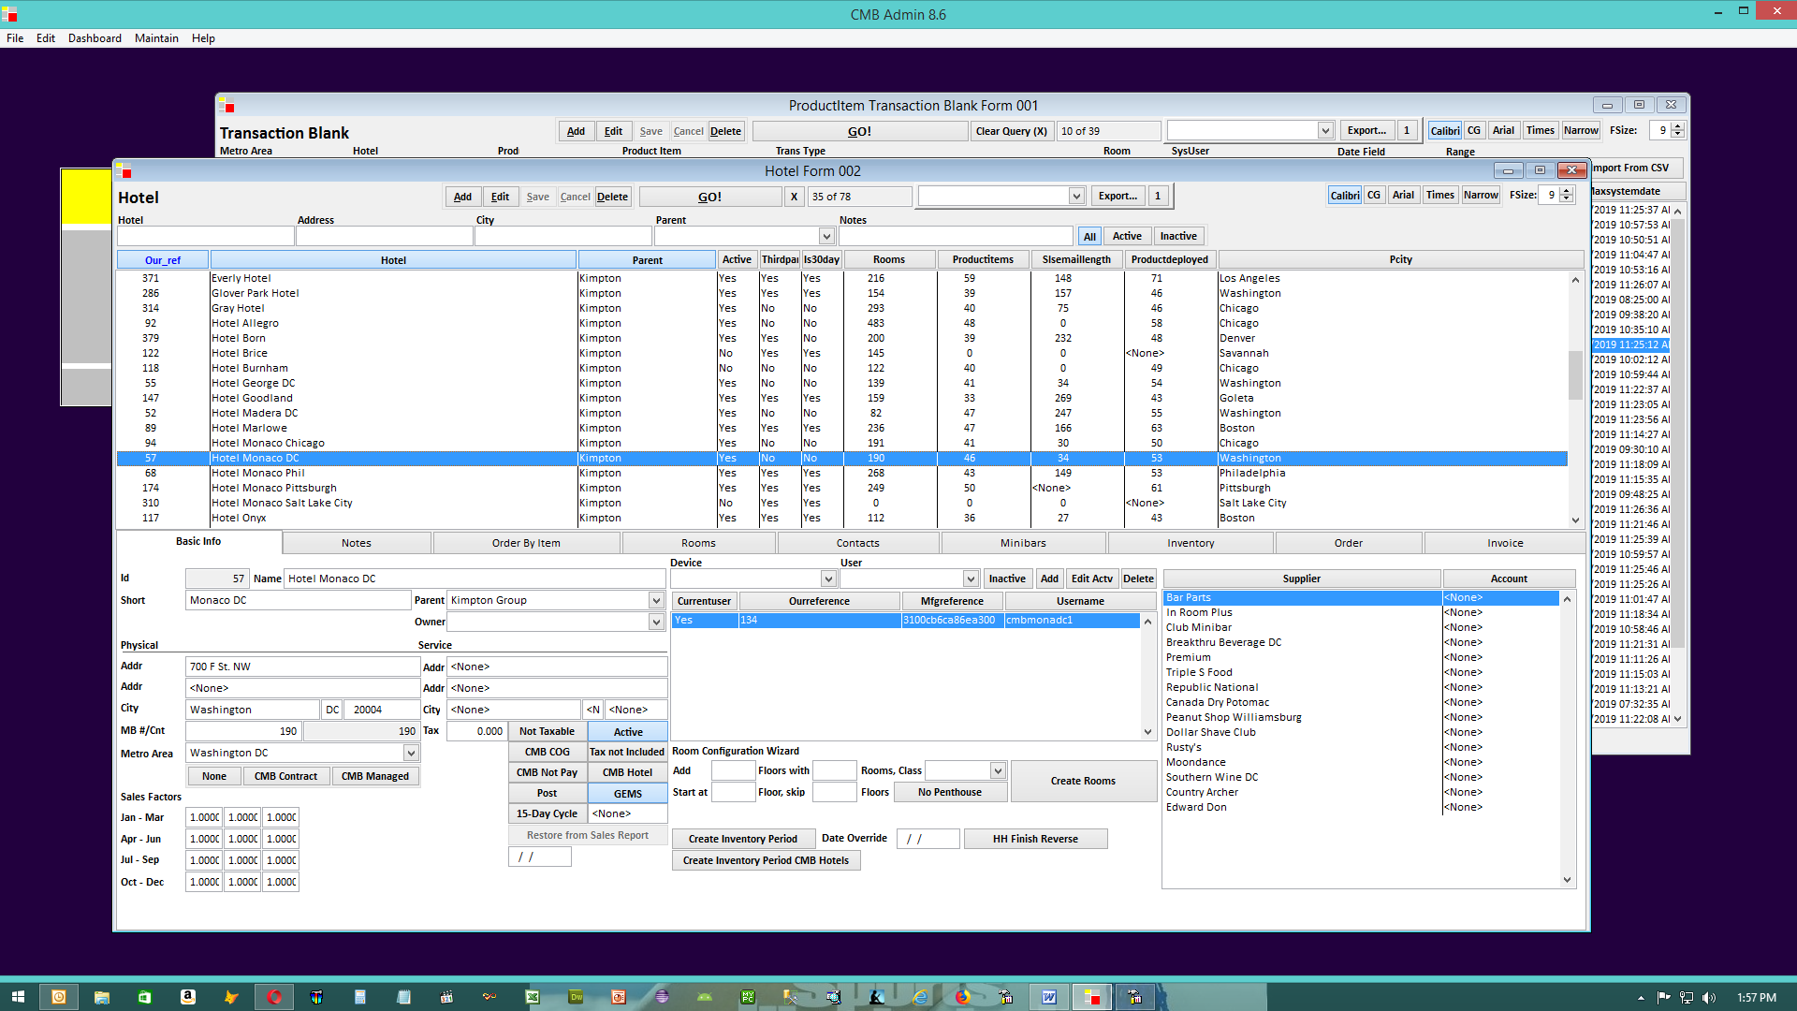

The Hotel Administration Screen in HMBMan

Club Minibar, Inc.

500 Sutter St.

Suite 901

San Francisco, CA 94102

Tel. (415) 834-1122

Club Minibar has developed an app called HMBman, short for Hotel Minibar Manager. We created the app based on our 20+ years in the hotel minibar business. The app is currently up and running in 36 hotels.

We use Google Nexus 7 tablets (pictured below) to collect minibar information at room level. The information is sent to our server over the hotel’s wi-fi.

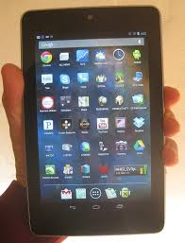

Our system has been designed to provide a complete minibar solution. This includes:
Recording sales at room level
Recording damaged and stale items at room level
Recording storeroom inventory as often as desired (e.g. weekly, 2x per month, monthly)
Calculating inventory variances item by item
Automating purchasing

The system can provide a wide range of reports including:

Consumption report by room, by item, by day, by month etc.
Profit and loss report by user, by day, by month etc.
Inventory Report
Inventory Variance Report
DND Report
Employee tracking

Another feature is our ability to sort data across multiple hotels. We can access data for one hotel or many. We can sort by metropolitan area or across all hotels managed by a management company.

The information collected is available to anyone with an internet connection.

Benefits: The benefit of HMBman is that it provides a complete data management solution for minibar managers. HMBman is a powerful tool which allows managers to quickly analyze data and make better merchandising decisions. Management companies benefit from being able to compare multiple properties at a moment’s notice. Minibar managers will also save time particularly in regard to preparing inventory reports and purchase orders.

Fees: We charge $200 per month per hotel for access to HMBman. The cost of the tablets is approximately $150. The protective case adds another $20.

There is no extended contract. The hotel can cancel the service at any time.
Demonstrations: We can provide on line demos.

Interfacing: HMBman can be interfaced to the hotel’s PMS.

Please direct questions to:

Tom Magowan
Club Minibar
415-834-1122 office
415-370-7145 cell

Appendix A1 – HMBMan Screens – Transaction Detail

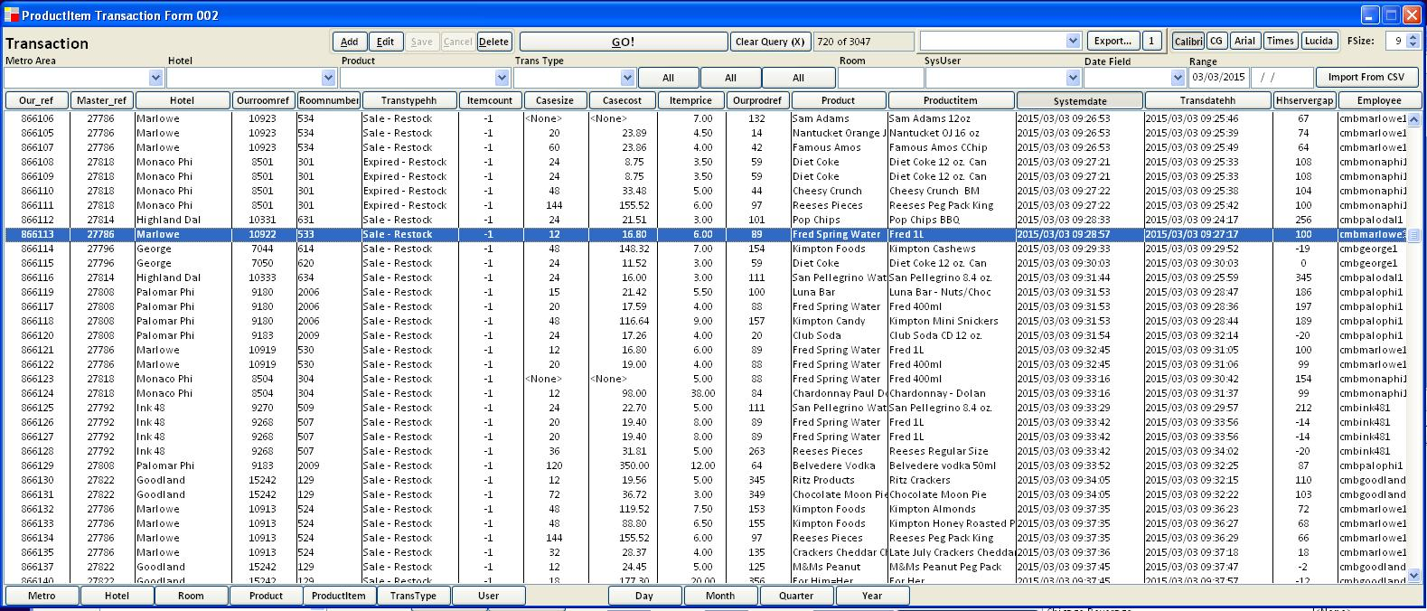

Appendix A2 – HMBMan Screens – Transaction Rollup By Hotel-Item (3-Click)

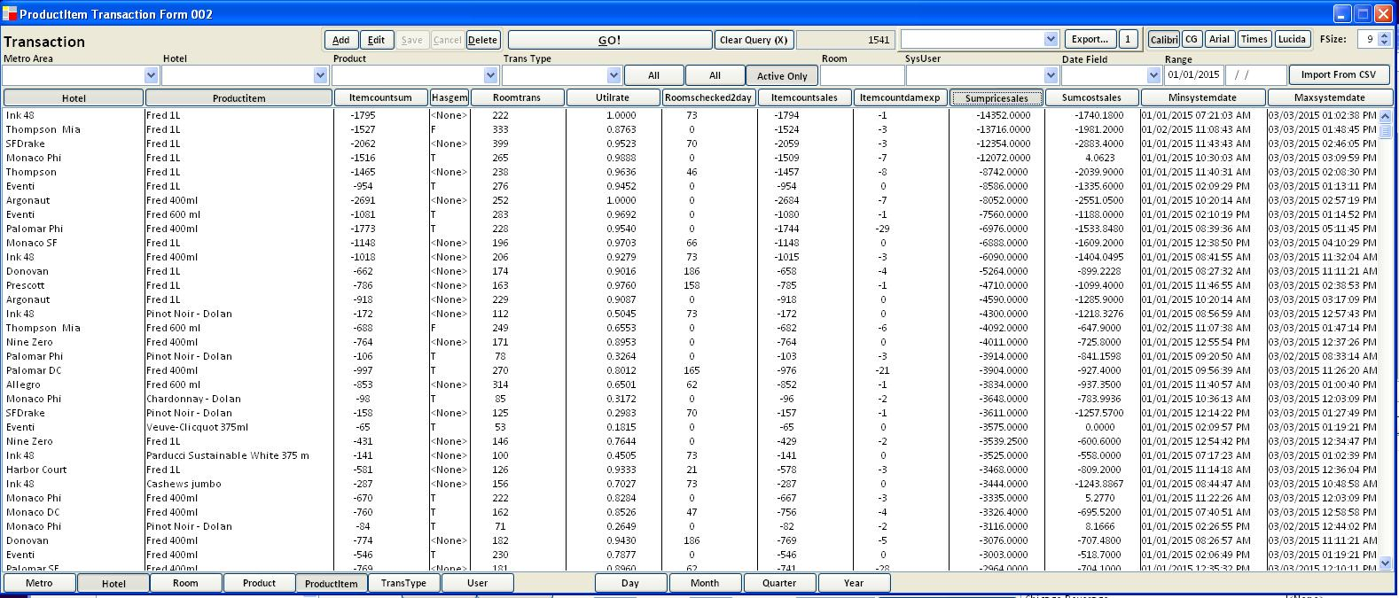
Sorted by descending dollars, Item, Hotel

Appendix A3 – HMBMan Screens – Transaction Rollup By Day (3-Click)

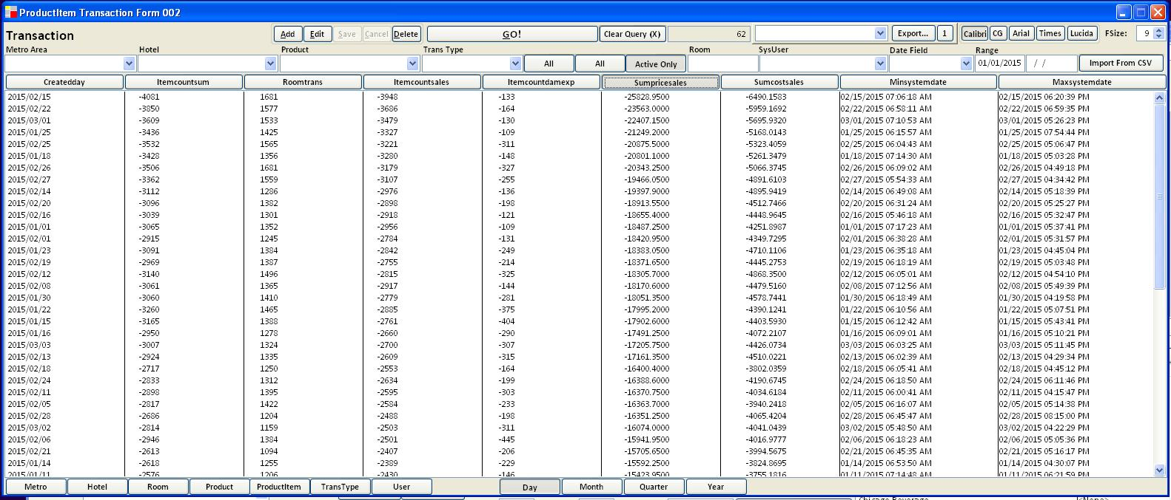
Sorted by Dollars Descending

Appendix A4 – HMBMan Screens – Hotels Live (Canned Real-Time Numbers)

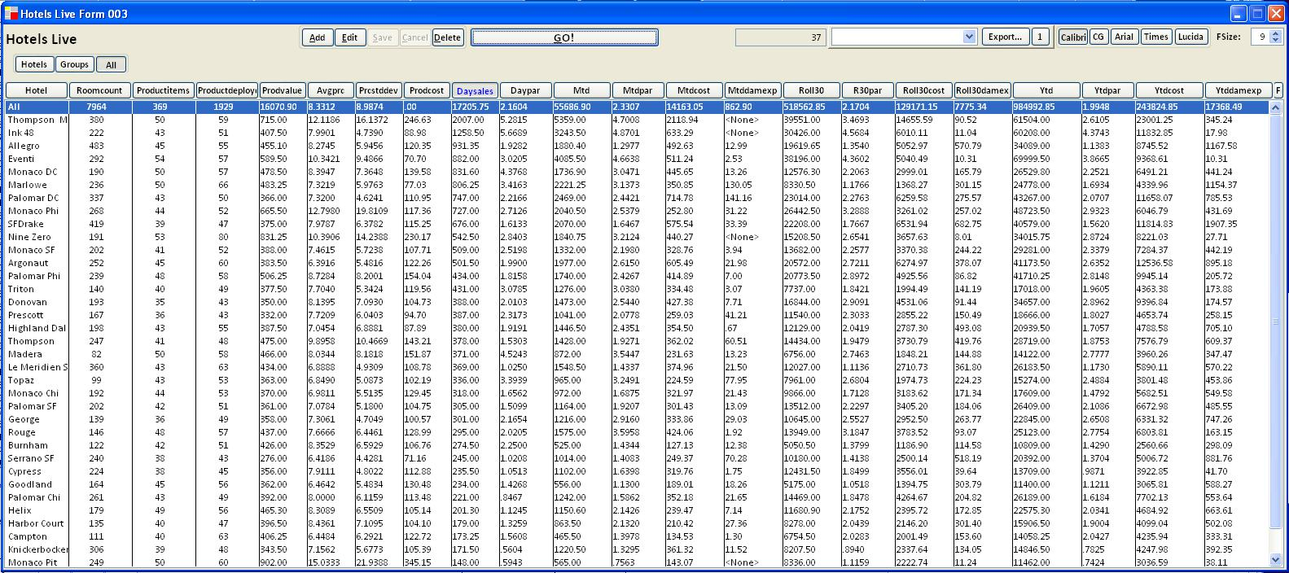

Appendix A5 – HMBMan Screens – Hotel Minibar Management
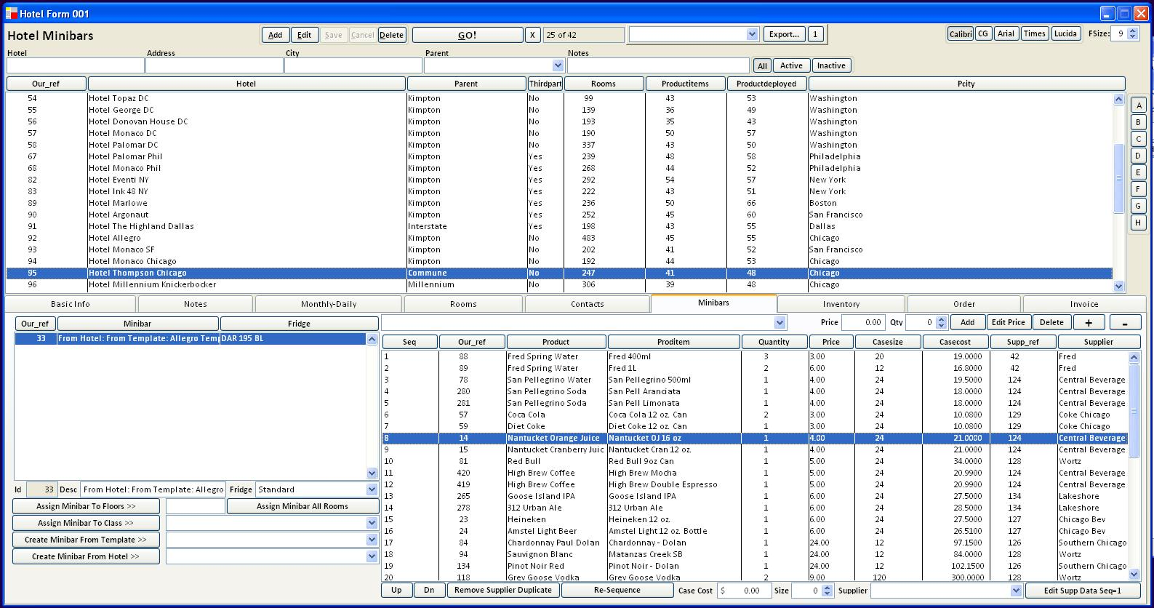

Appendix A6 – HMBMan Screens – Hotel Contacts and Report Distribution
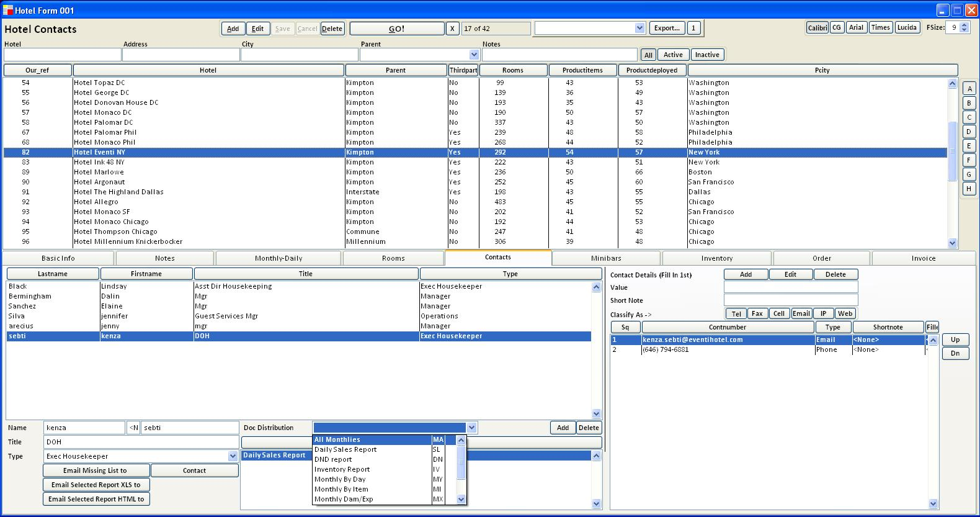

Appendix A7 – HMBMan Screens – Purchase Order Generation
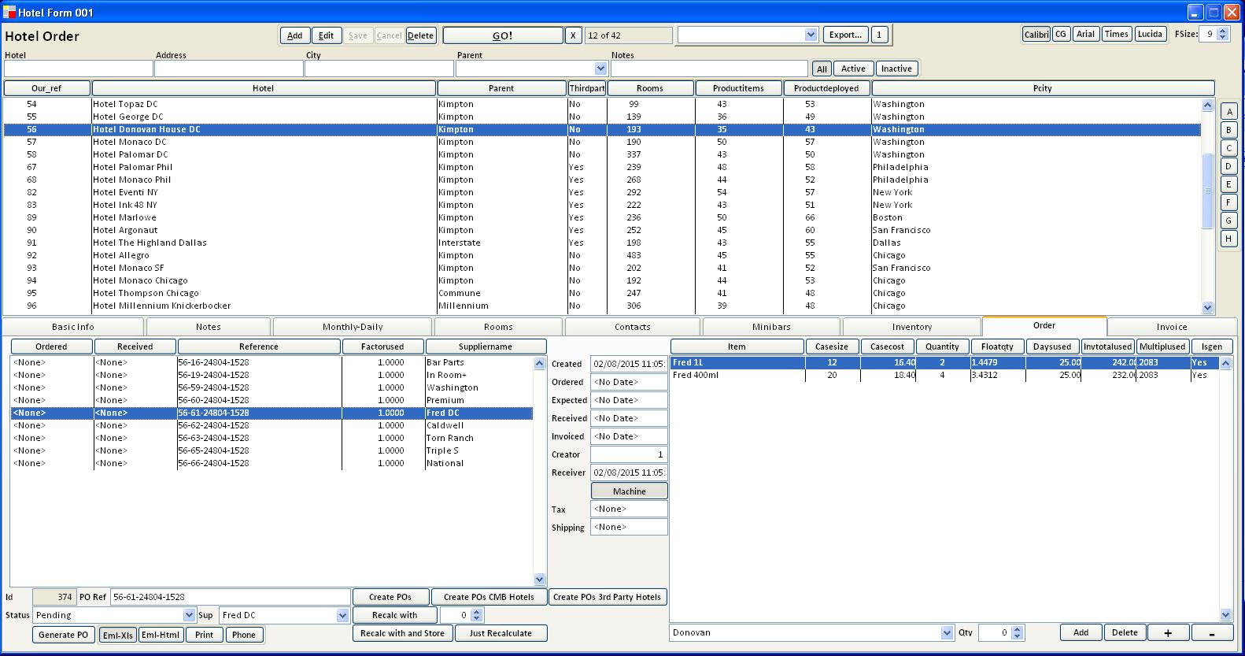

Appendix A8 – HMBMan Screens – Inventory

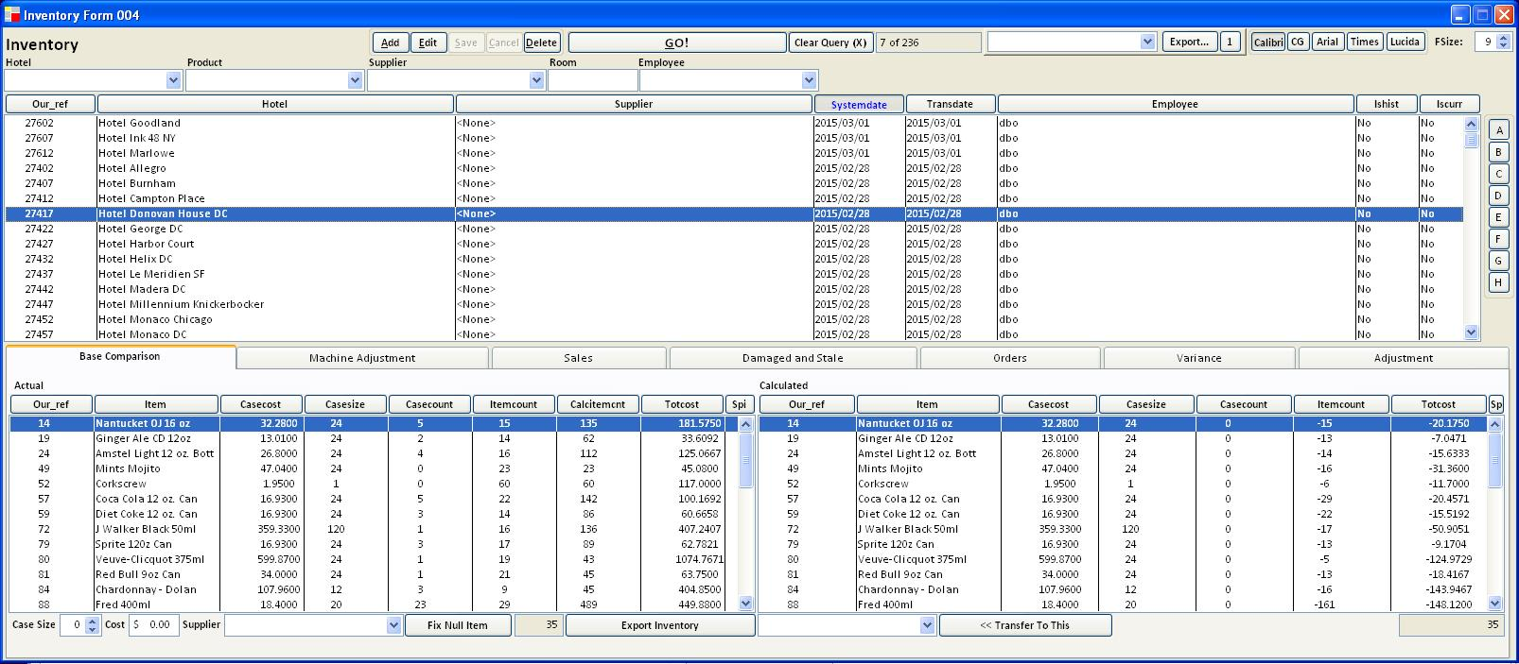

Appendix A9 – HMBMan Screens – Suppliers
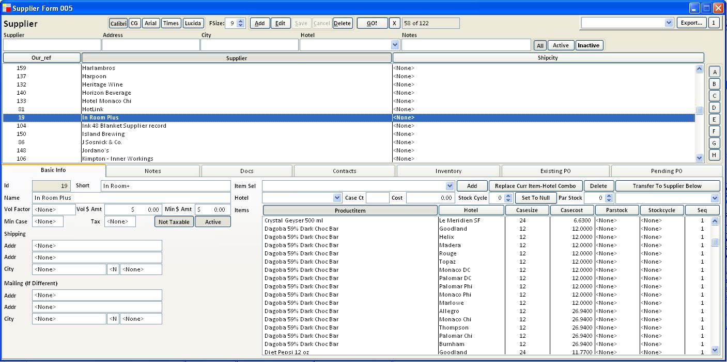

Appendix A10 – HMBMan Screens – Product-Items
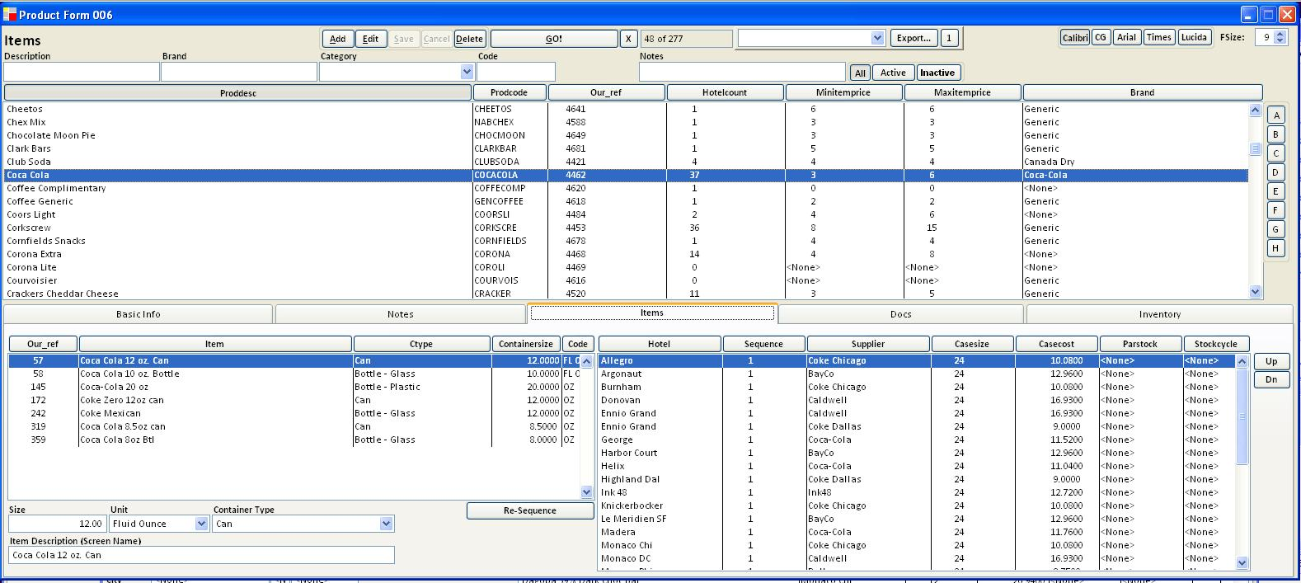

Appendix A11 – HMBMan Screens – Room Status

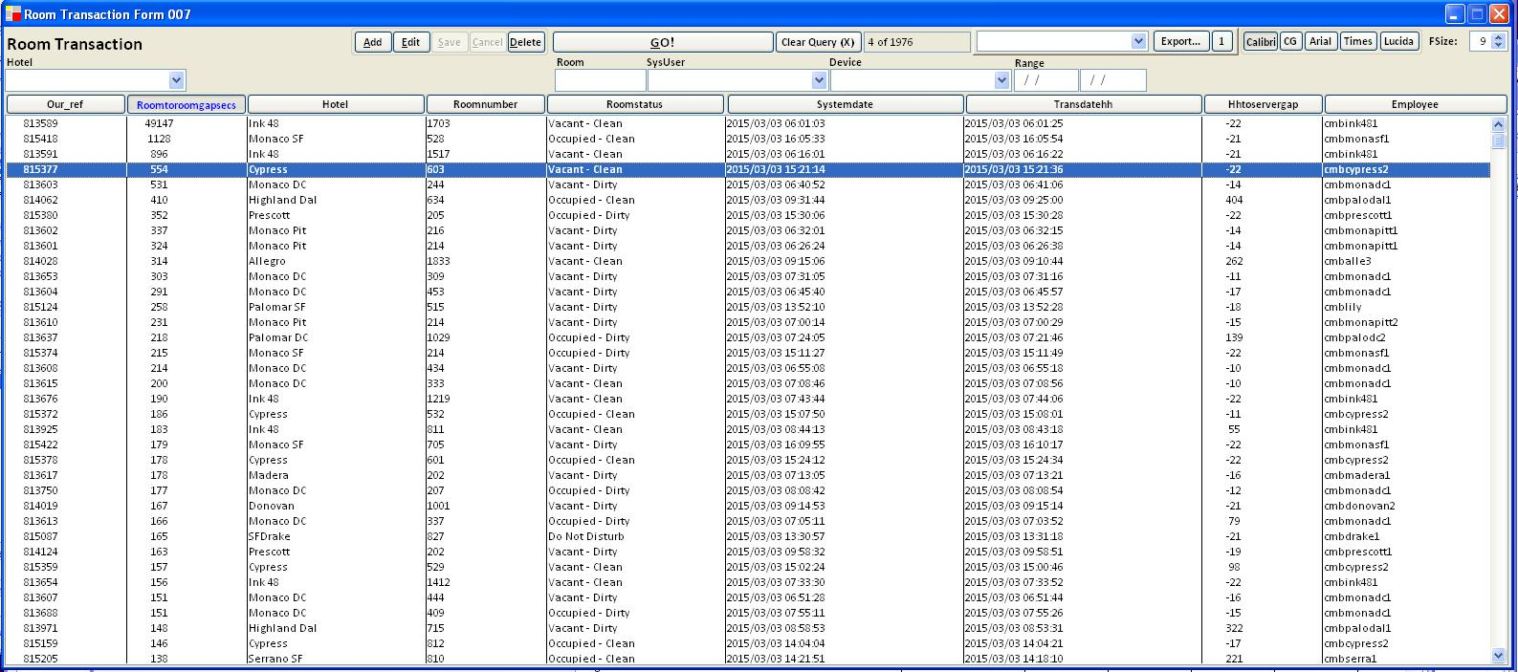

Appendix A12 – HMBMan Screens – Shift Log

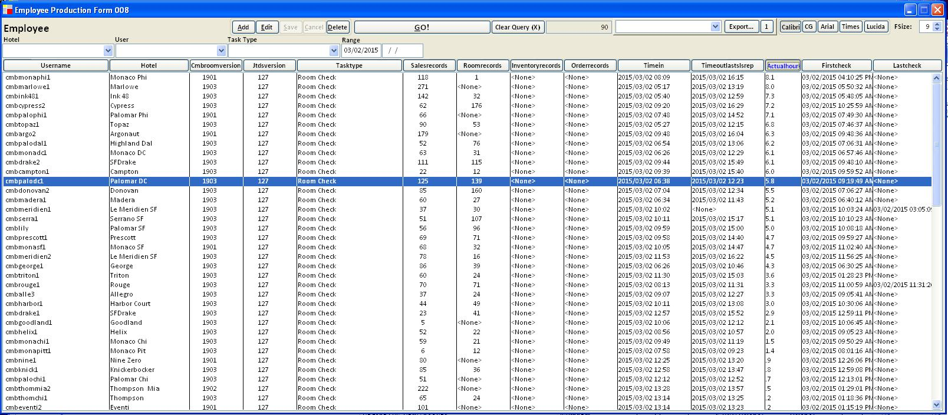

Appendix B - CMBRoom Quick Reference 1.9.0.3
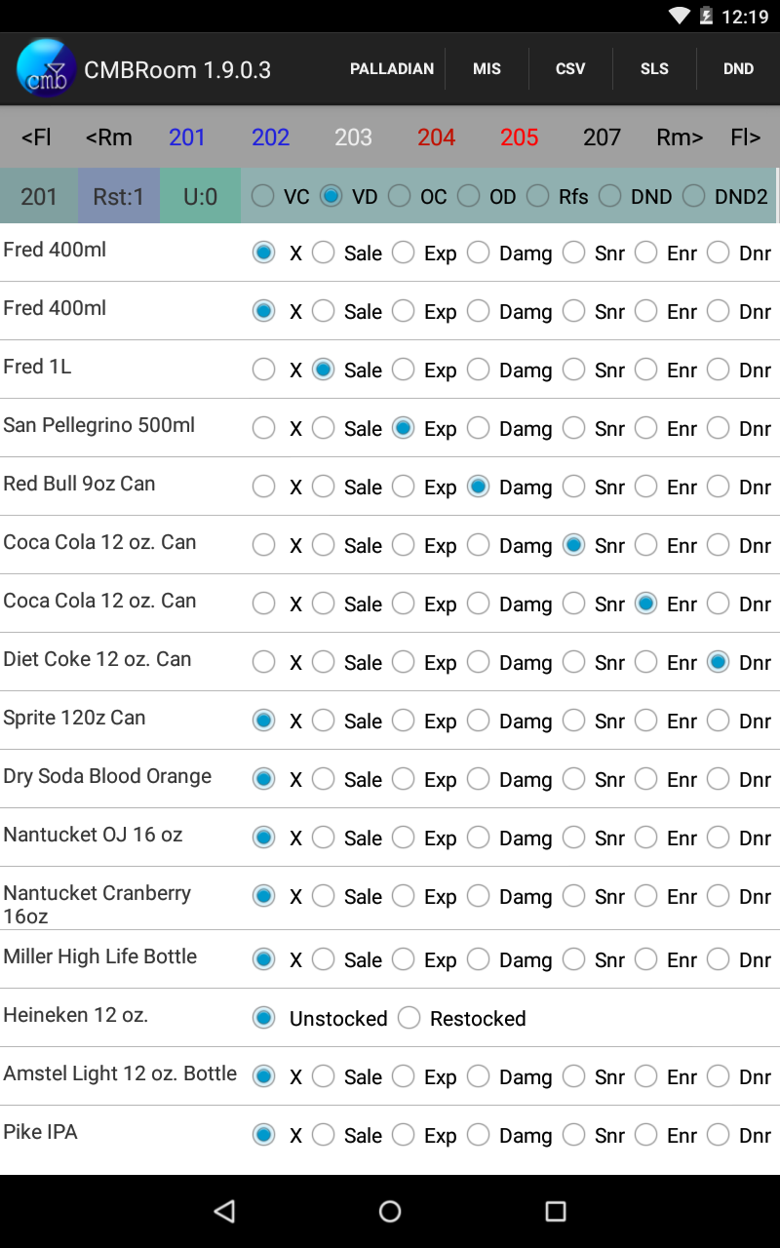

Objects Top to Bottom
CMBR 1.8.9 – Current Version
Ennio Grand – Hotel Name Button sends Sales Report to Adobe Reader instead of Email
CSV – Generates a computer-readable version of INT for import by HMBMan
SLS – PDF Sales report sent to default Email App with user-defined distribution
DND – PDF DND Report defaults to Adobe Reader
<Fl – Previous Floor (bottom of)
<Rm – 6 Previous Rooms
(Blue) -> Colour indicates VC-VD-OC-OD
(White) -> Refused Service (“Please Go Away”)
(Dim Red) -> DND (Do Not Disturb)
(Bright Red) -> DND2 (DND Re-check)
(Black)-> No Room Status Recorded
Rm> Ensuing 6 Rooms
Fl> Next Floor
708 – Current Room
Rst:0 – Number of Day’s restock Items in Room
U:0 –Transactions in HH remaining unsent to DB server. Switch rooms to send or check
VC – Vacant Clean
VD – Vacant Dirty
OC – Occupied Clean
OD – Occupied Dirty
Rfs – Refused Service
DND – Do Not Disturb
DND2 – DND Re-check (later)
Product List Action Buttons-> X – None Sale Exp – Expired Damg – Damaged
Snr – Sale No restock Enr – Expired No Restock Dnr – Damaged No Restock

Remember
App sends transactions between rooms. Never end a day with U>0. Keep switching rooms, be patient in bad Wifi
Plugging HH into a Windows 7/8 station will yield a “Nexus 7” Drive in “Computer”. Within this, Find the Android\Downloads folder. In no wifi emergencies, the sales report PDF and the CSV file will be here (if generated, see above). See HMBMan Quick Reference for CSV Import procedures.

App Prerequisites
Adobe Reader
Any Gmail Account (Nexus 7 prerequisite).
Wifi at Day Start
Wifi at Close
Please – Turn OFF and recharge overnight.

Using Adobe Reader
Pinch/Unpinch to Zoom
Sending Email – Select 3 Dots (Settings) – Share Menu Item, Pick desired App from list.
Please close Adobe Reader before re-printing a report. Reader makes open files inaccessible to our App.

Clearing Data after New Products or Problems
To reload all data (new products, rooms, email distribution):
- Make sure you have a good Wifi connection
- Swipe from Top Right, select “Settings”
- Select “Apps” in the list
- Select “CMBRoom” in the Apps list
- Press “Clear Data”, Confirm, and open CMBRoom again

Notes about Restocking
When you select any of: SNR/DNR/ENR, you are telling the server that you were not able to replace the item in the fridge. As a consequence of this, on the following day, the item will have 2 buttons instead of 6. The first, “Unstocked”, will be checked. The item can stay this way for days – until you have it to replace; you will then press the second button, “Restocked.” The day after you press it, that item’s buttons will return to normal.

Notes about the tablet
3 Buttons at the bottom:

Right Button – Previous Screen
Middle Button – Home Screen
Left Button – Recent/Active Apps

A Note about Recent Apps
This is the button you use to make sure an app is closed. If you see an app you would like to close, like Adobe Reader for instance, swipe your finger sideways over it until it disappears.

A Note about WiFi
Wifi, unfortunately, can be very spotty. WiFi can also indicate “Bars” when there is really little connectivity. It can also take 10-60 seconds to come back even when you see bars. At the beginning of a day, try to turn the tablet on when already in a ‘good’ zone. WAIT 30 seconds-1 Minute or so before entering the app to be certain the day starts.
This can also apply to unsent transactions in a bad WiFi Zone. Patience is a good idea.

A Note about Restarting the App
The first time you install this version (and anytime you “clear data”, the “Hotel Name” button at the top will read “PDF” – but it will function. The menu now displays BEFORE the server has a chance to return the hotel name. If you close and re-open the App, you will see the hotel.

A Note about Power
The USB cable provided for the unit is cheesy and flimsy; there are no sturdy alternatives, at least in a reasonable price range, but the good news is that the cable is available almost anywhere for $3-5.

Given the above, it is a good idea to check that unit really charged overnight. If it didn’t and it was plugged in correctly, the cable is likely to blame and should be replaced. If the cable works intermittently (as some will), you may want to delay a shift 30-45 minutes for a recharge.

We have discovered that extended use on low battery can lead to fairly serious hardware problems, including tablets that stop working completely.

Setting Brightness on the unit to a low value (20-30% on the slider) keeps the unit powered for much longer stretches whilst remaining quite legible in most light.

Appendix C - CMB Inventory 1.0.2
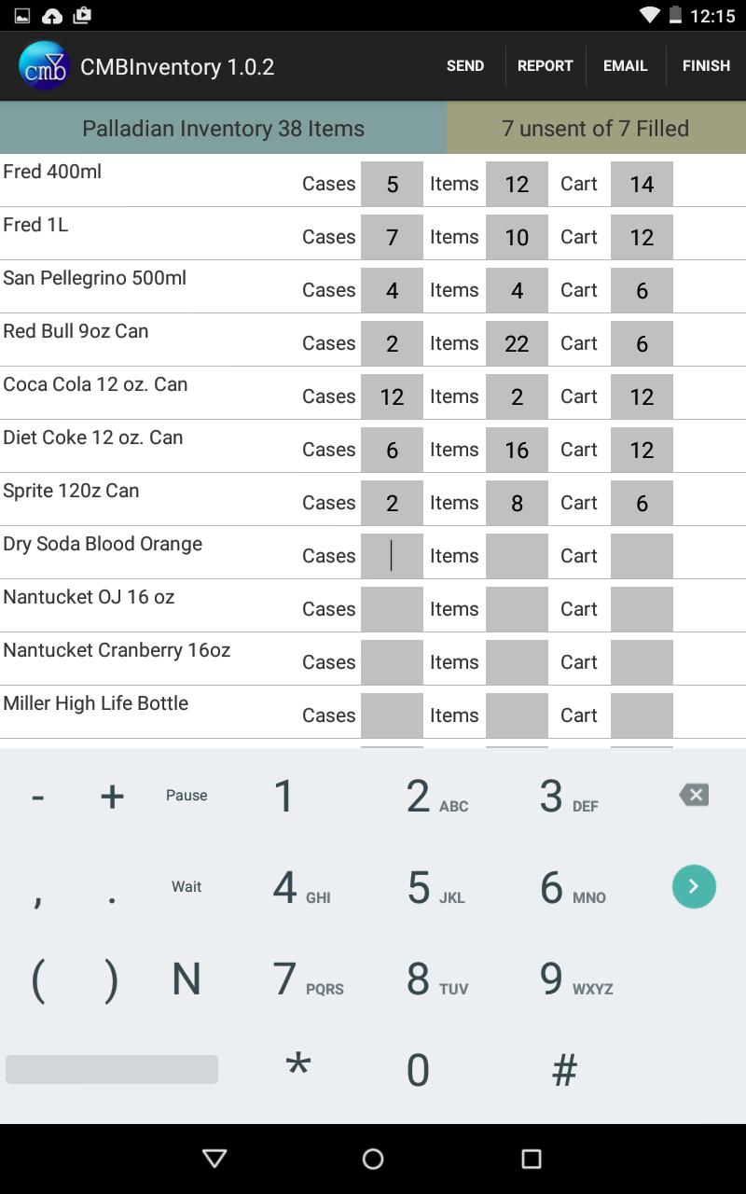

Inventory Quick Reference
- Ensure inventory period has started
- Fill whole case counts in column 1
- Fill partial case counts in column 2
- Fill item counts from carts in column 3
- Press ‘Send’ when wifi is available
- Correct any mistakes and repeat ‘Send.’ Values will be overwritten
- the ‘Filled’ count is by row, not cell
- Ensure ‘unsent’ count is 0
- View inventory report with ‘Report’ button
- Email the same report to distribution with ‘Email’
- Once you are certain everything is done, press finish
- Call CMB or ELAG to reverse the finish in case an error got through
- To ensure the integrity of the counts, Inventory is NOT available outside inventory day

